# Web concept: Understanding CRUD

* Create, retrieve, update and delete (CRUD) refers to the four major functions implemented in database applications.
* The commands corresponding to these operations in SQL are-
* INSERT
* SELECT
* UPDATE
* DELETE

From there we can subsequently add "add_info" page, "List" page, "Update" page and finally "Delete" page.

**Creating a sample Database table**

We will work on a simple Database table as below. We should use the idea here to create CRUD on our own Database tables.

CREATE TABLE `users` (

`id` int(10) NOT NULL AUTO_INCREMENT,

`firstName` varchar(255) NOT NULL,

`lastName` varchar(255) NOT NULL,

`phoneNumber` varchar(255) NOT NULL,

PRIMARY KEY (`id`)

)

**Connect to Database**

Create a PHP file "connect.php", this file related to database connections, such as connecting and disconnecting.

***Code: connect.php***

<?php

$con=mysqli_connect("localhost","root","","students") or die("Error: ".mysqli_error($con));

?>

We will need to supply correct values for $dbName, $dbHost, $dbUsername, $dbUserPassword.

* **$dbName**: Database name which you use to store 'customers' table.
* **$dbHost**: Database host, this is normally "localhost".
* **$dbUsername**: Database username.
* **$dbUserPassword**: Database user's password.

1. **INSERT**

Inserting data using a web form we should have to follow the following actions-

1. Form Action
2. Post Method
3. Name of Field
4. Submit Type

***Code: index.html***

<h2 align="center"> Registration Form </h2>

<table border="1" width="70%" align="center" cellpadding="2" cellspacing="0">

<form action="add_info.php" method="post">

<tr> <td> <label>First Name: </label></td>

<td> <input type="text" name="fname" title="Enter the First Name" required />

<br /></td></tr>

<tr><td>

<label>Last Name: </label></td>

<td><input type="text" name="lname" title="Enter the Last Name" required />

<br /></td>

<tr> <td>

<label>Phone Number: </label></td>

<td> <input type="text" name="pnumber" title="Enter the phone number" required />

<br /></td></tr>

<br />

<tr align="center"><td colspan="2"> <input type="submit" value="Submit" name="insert"/>

</form>

<tr><td colspan="2">

<a href="list.php"><b>Goto List</b></a> </td></tr>

</table>

After

***Code: add_info.php***

<?php

include('connect.php');

$query="INSERT INTO `students`.`users` (`id`, `first_name`, `last_name`, `phone_number`) VALUES ('', '$_POST[fname]', '$_POST[lname]', '$_POST[pnumber]');";

if(mysqli_query($con,$query))

echo "Successfully added 1 record into Database";

else

die("Error: ".mysqli_errno($con));

?>

<!DOCTYPE html>

<html>

<head>

<title></title>

</head>

<body>

<br />

<a href="index.html"><b>Back</b></a>

</body>

</html>

<?php mysqli_close($con);?>

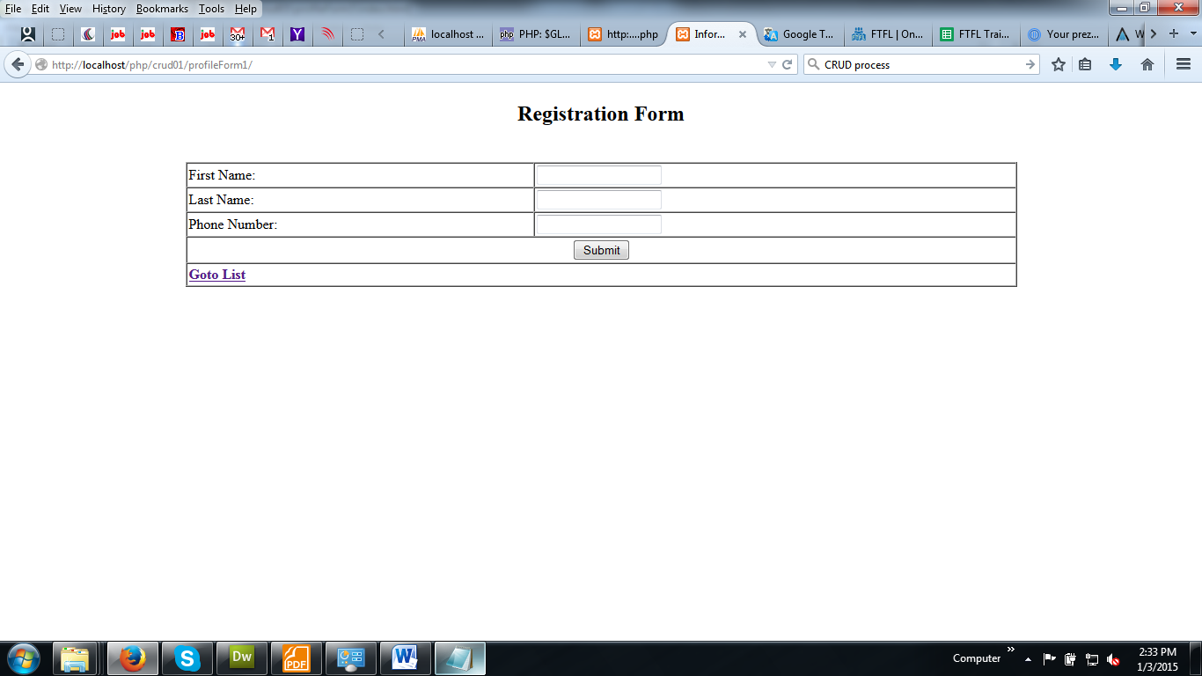

1. **SELECT**

Select data from the Database -

***Code: list.php***

<?php

include('connect.php');

if(isset($_POST['update'])){

$update_id=$_GET['id'];

if(isset($update_id)){

$sql = "UPDATE users SET firstName='$_POST[fname]',lastName='$_POST[lname]',phoneNumber='$_POST[pnumber]' WHERE id=$update_id";

mysqli_query($con,$sql);

}

}

$query="SELECT * FROM users";

$result=mysqli_query($con,$query);

?>

<!DOCTYPE html>

<html>

<head>

</head>

<body>

<h2 align="center"> List </h2>

<table border="1" align="center" width="60%">

<thead>

<tr>

<th>ID</th>

<th>First Name</th>

<th>Last Name</th>

<th>Phone Number</th>

<th>Action</th>

</tr>

</thead>

<tbody>

<?php foreach($result as $row){ ?>

<tr align="center">

<td><?php echo $row['id'] ?></td>

<td><?php echo $row['firstName'] ?></td>

<td><?php echo $row['lastName'] ?></td>

<td><?php echo $row['phoneNumber'] ?></td>

<td><a href="update.php?id=<?php echo $row['id']?>">Edit</a> / <a href="delete.php?id=<?php echo $row['id'] ?>" onClick="return confirm('Are you sure want to delete id = <?php echo $row['id'] ?> ?');">Delete</a></td>

</tr>

<?php } ?>

</tbody>

<tfoot>

<tr>

<td align="left" colspan="5"><a href="index.html"><b>Add a new record</b></a></td>

</tr>

</tfoot>

</table>

</body>

</html>

<?php mysqli_close($con);?>

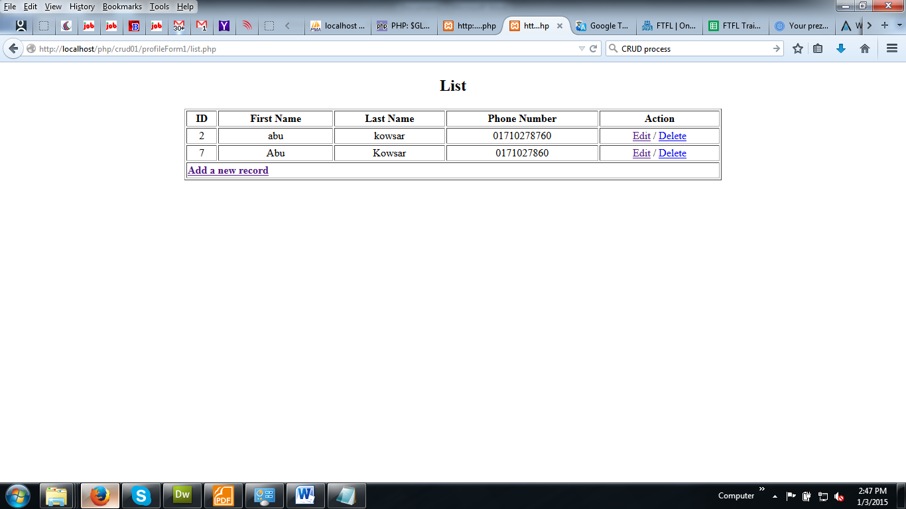

1. **UPDATE**

Update a data to the Database –

***Code: update.php***

<?php

include('connect.php');

$id=$_GET['id'];

$query="SELECT * FROM `students`.`users` WHERE `users`.`id` = $id";

$result=mysqli_query($con,$query);

$rows=mysqli_fetch_array($result);

?>

<!DOCTYPE html>

<html>

<head>

<title>Information Form</title>

</head>

<body>

<h2 align="center"> Edit Form </h2>

<table border="1" width="70%" align="center" cellpadding="2" cellspacing="0">

<form action="list.php?id=<?php echo $_GET['id'] ?>" method="post">

<input type="hidden" id="update_id" value="<?php echo $id ?>" />

<tr> <td> <label>First Name: </label></td>

<td> <input type="text" name="fname" title="Enter the First Name" value="<?php echo $rows['firstName']?>" required />

<br /></td></tr>

<tr> <td> <label>Last Name: </label></td>

<td><input type="text" name="lname" title="Enter the Last Name" value="<?php echo $rows['lastName']?>" required />

<br /></td></tr>

<tr> <td> <label>Phone Number: </label></td>

<td> <input type="text" name="pnumber" title="Enter the phone number" value="<?php echo $rows['phoneNumber']?>" required />

<br /></td></tr>

<tr> <td colspan="2" align="center">

<input type="submit" value="Update" name="update" />

</form>

</td></tr>

<tr> <td colspan="2" align="left">

<br />

<a href="list.php"><b>Goto List</b></a>

</td></tr>

</table>

</body>

</html>

<?php mysqli_close($con);?>

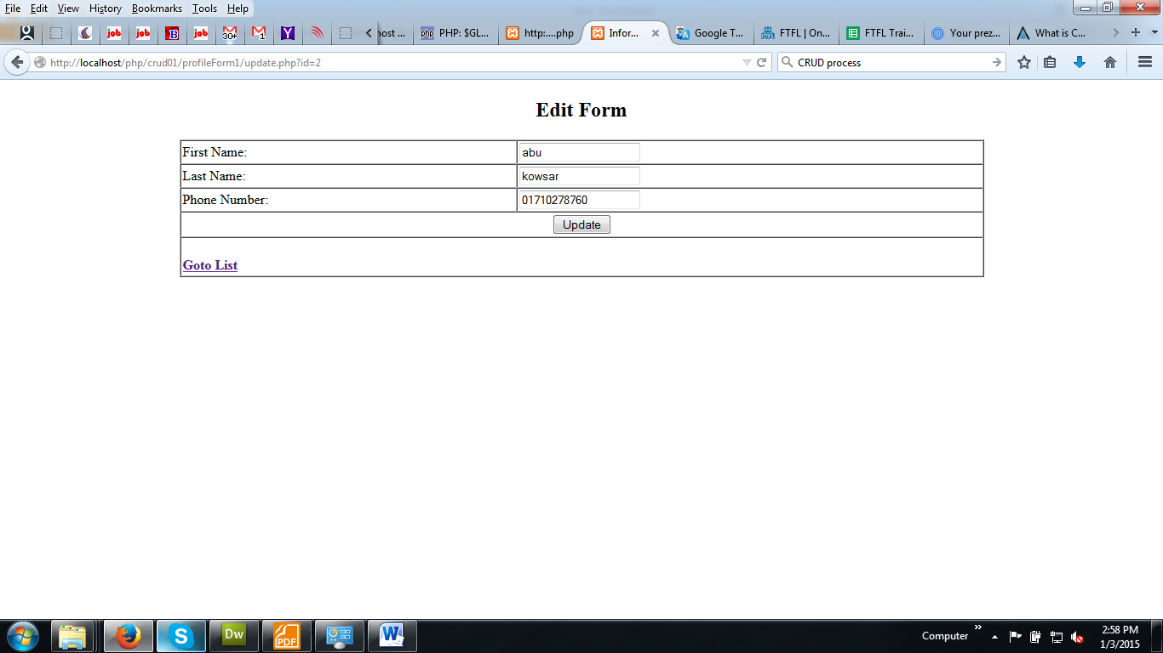

1. **DELETE**

Delete a data from the Database –

***Code: delete.php***

<?php

include('connect.php');

$id=$_GET['id'];

$query="DELETE FROM `students`.`users` WHERE `users`.`id` = $id";

mysqli_query($con,$query);

header('location: list.php');

mysqli_close($con);

?>

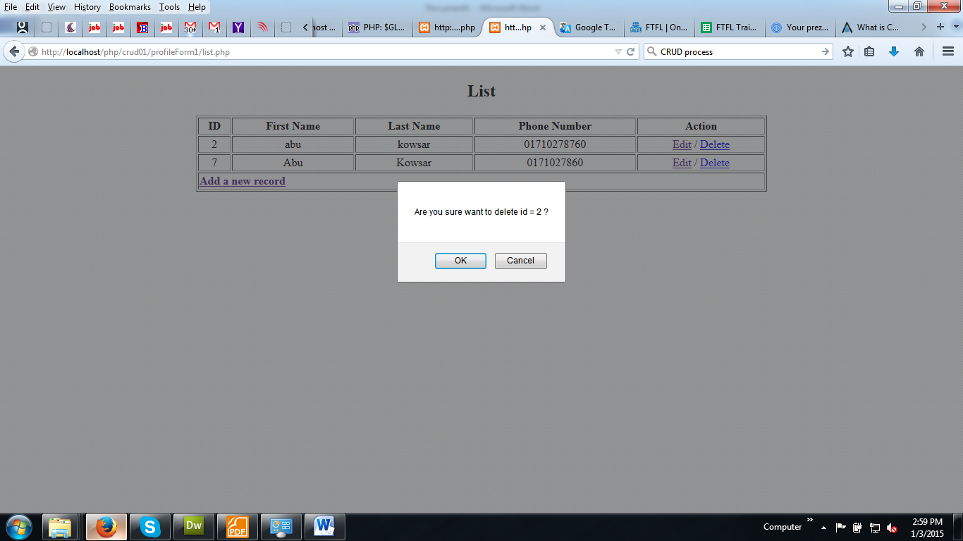

This article covered some basic CRUD operations on a database via PHP and MYSQL. Hope this article helped to get some basic idea of how to make database connection, create a table, insert, update, read and delete records.